**USERS table**

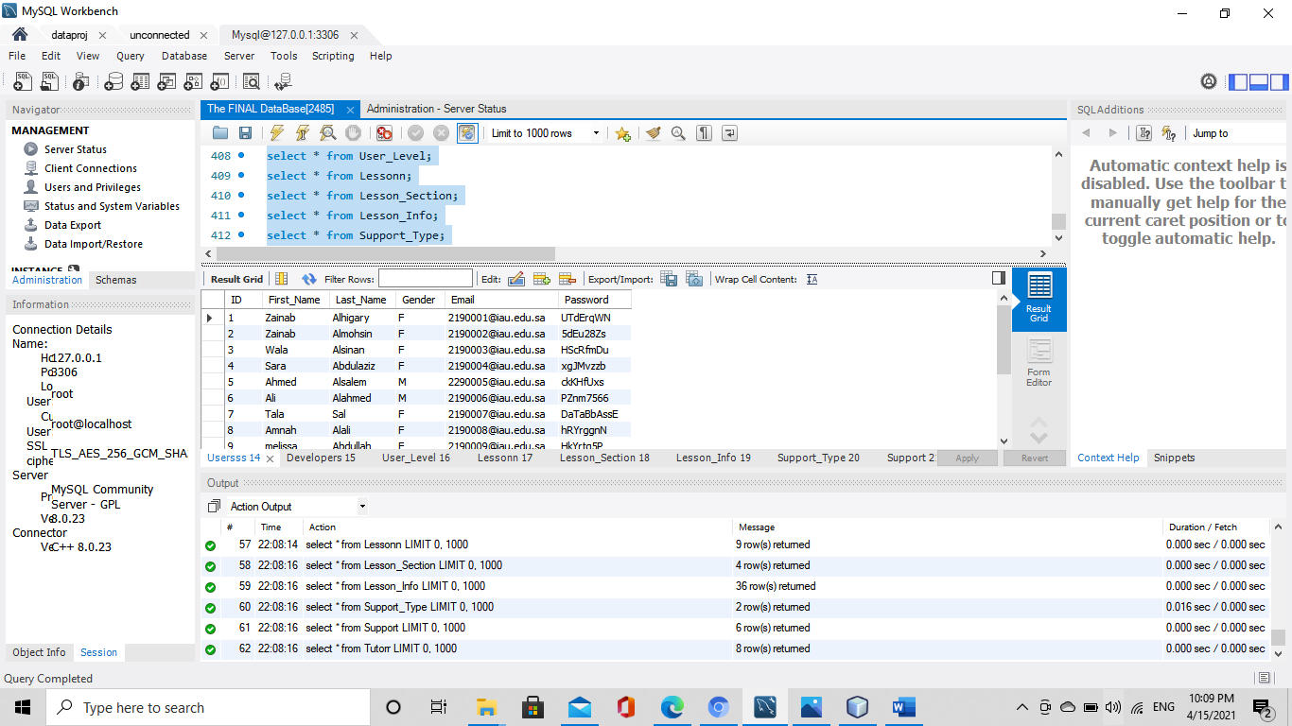

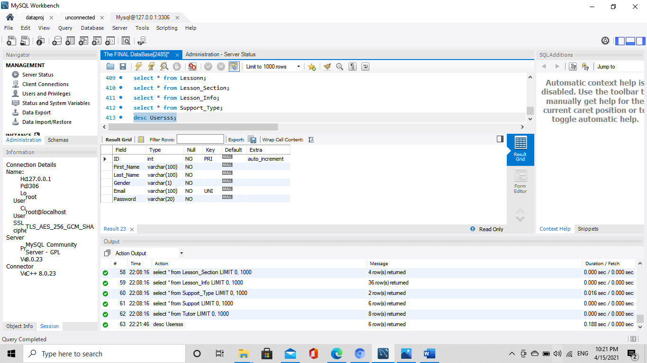

REATE TABLE Usersss (

ID int(11) NOT NULL AUTO_INCREMENT,

First_Name varchar(100) NOT NULL,

Last_Name varchar(100) NOT NULL,

Gender varchar(1) NOT NULL,

Email varchar(100) NOT NULL,

Address varchar(30) NOT NULL,

Password varchar(20) NOT NULL,

PRIMARY KEY (ID),

UNIQUE KEY Email (Email)

);

**Developer table**

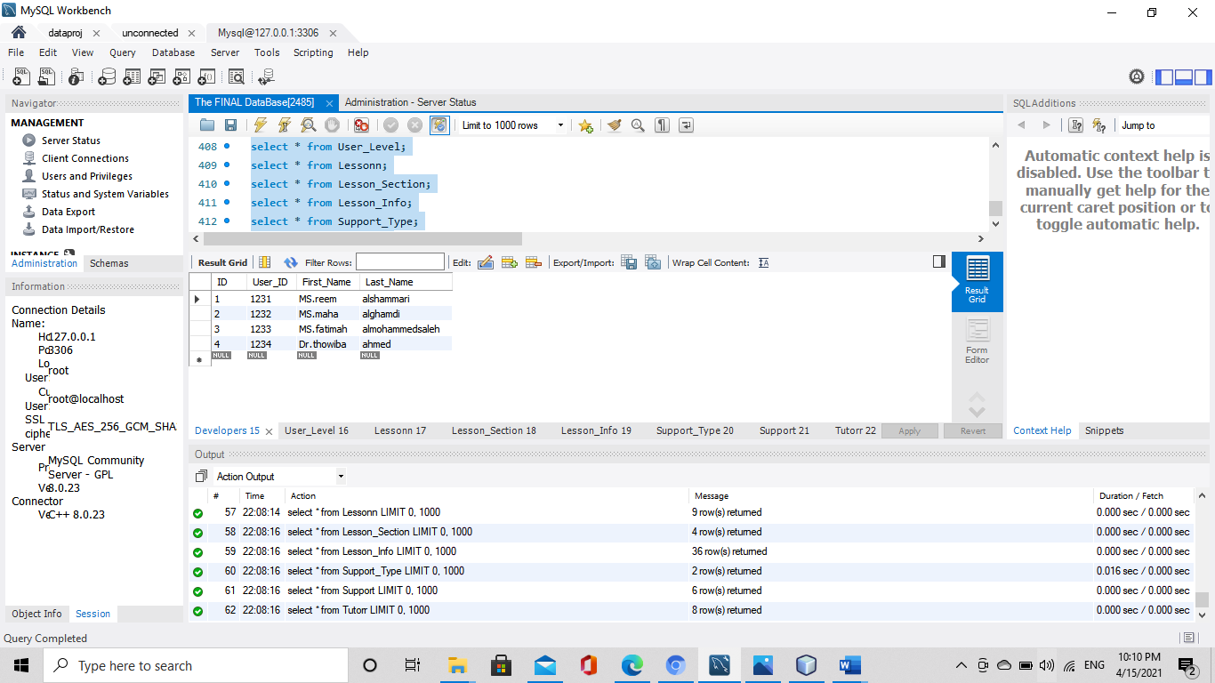

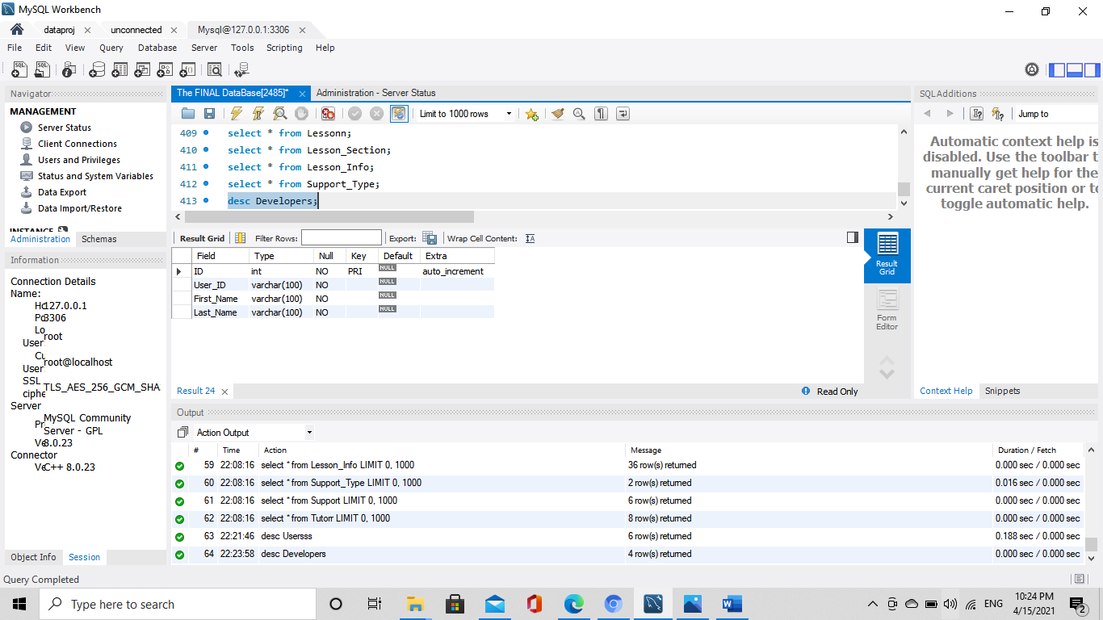

create table Developers (

ID int(11) NOT NULL AUTO_INCREMENT,

User_ID varchar(100) NOT NULL,

First_Name varchar(100) NOT NULL,

Last_Name varchar(100) NOT NULL,

PRIMARY KEY (ID)

);

User_Level table

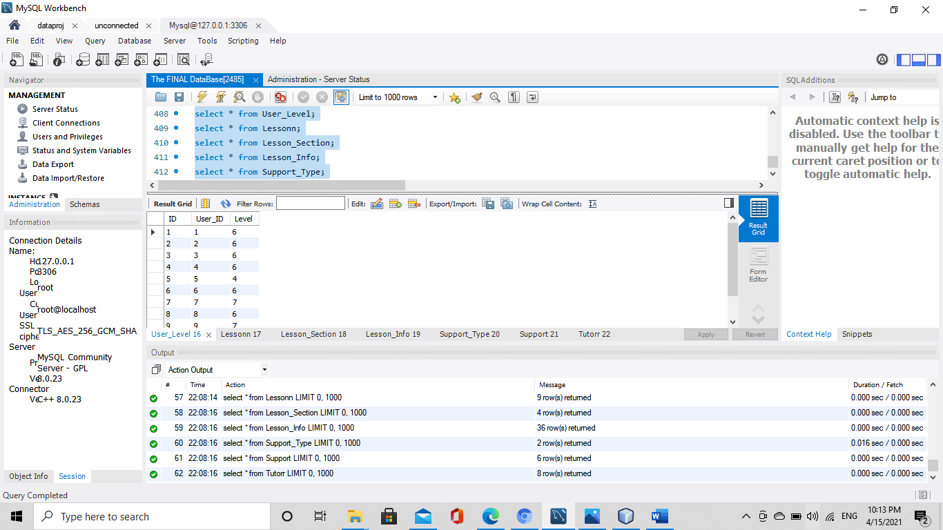

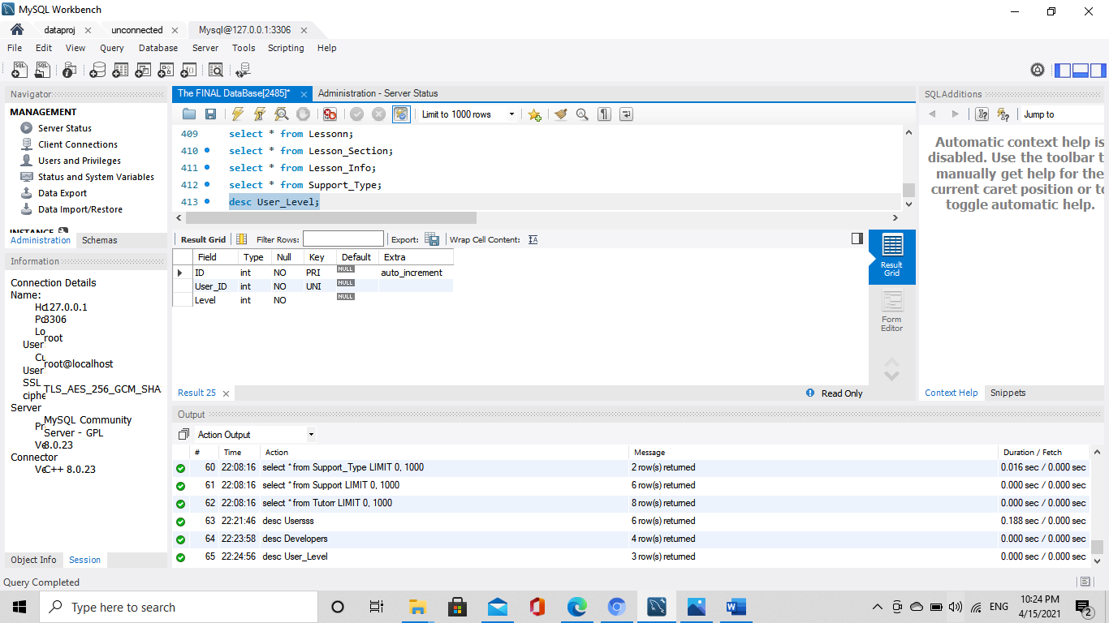

CREATE TABLE User_Level (

ID int(11) NOT NULL AUTO_INCREMENT,

User_ID int(11) NOT NULL,

Level int(11) NOT NULL,

PRIMARY KEY (ID),

UNIQUE KEY User_ID_2(User_ID),

KEY User_ID (User_ID)

);

Lesson table

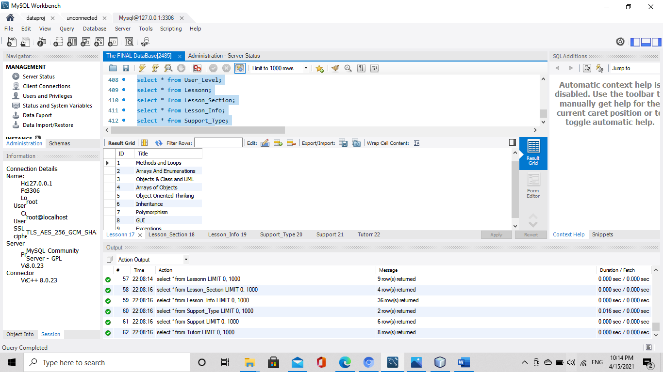

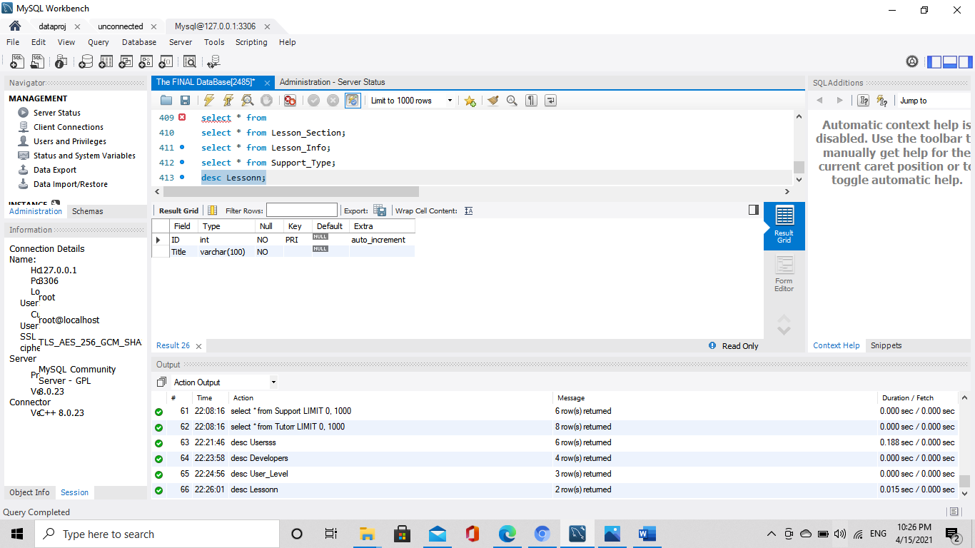

CREATE TABLE Lessonn (

ID int (11) NOT NULL AUTO_INCREMENT ,

Title varchar(100) NOT NULL,

PRIMARY KEY (ID)

);

Lesson_Section table

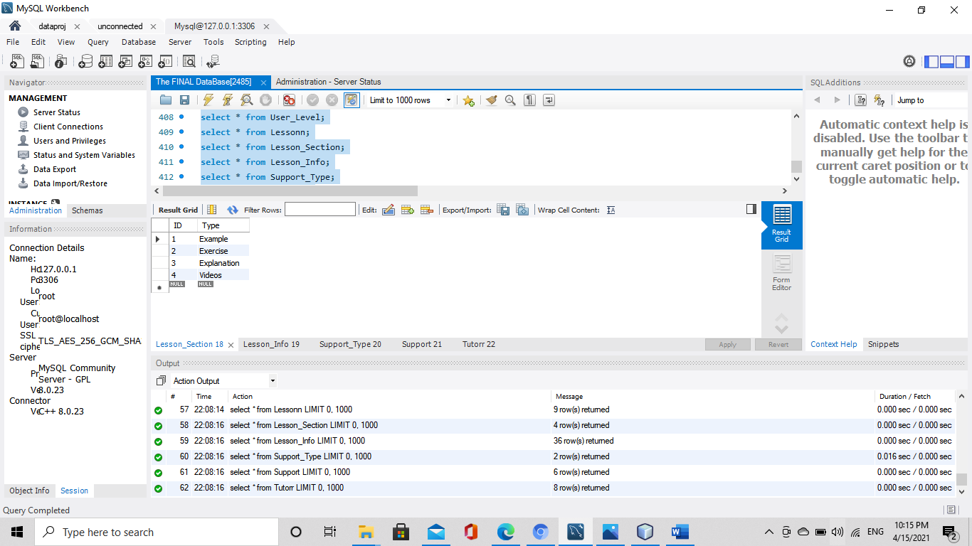

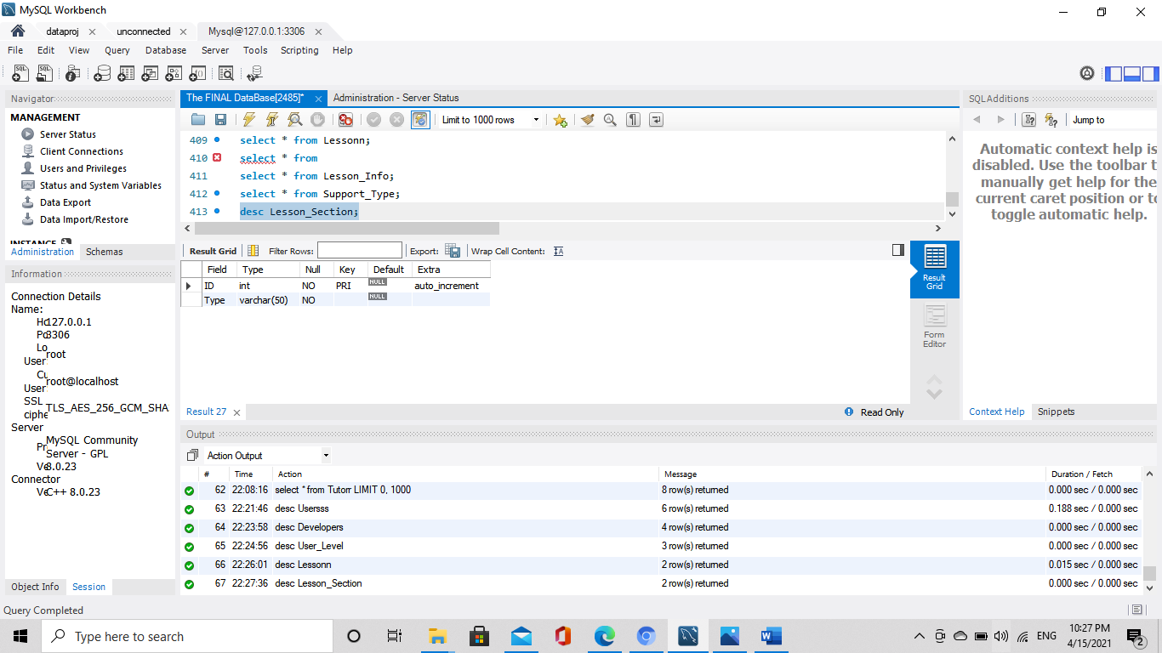

CREATE TABLE Lesson_Section (

ID int(11) NOT NULL AUTO_INCREMENT,

Type varchar(50) NOT NULL,

PRIMARY KEY (ID)

);

Lesson_inforamtion

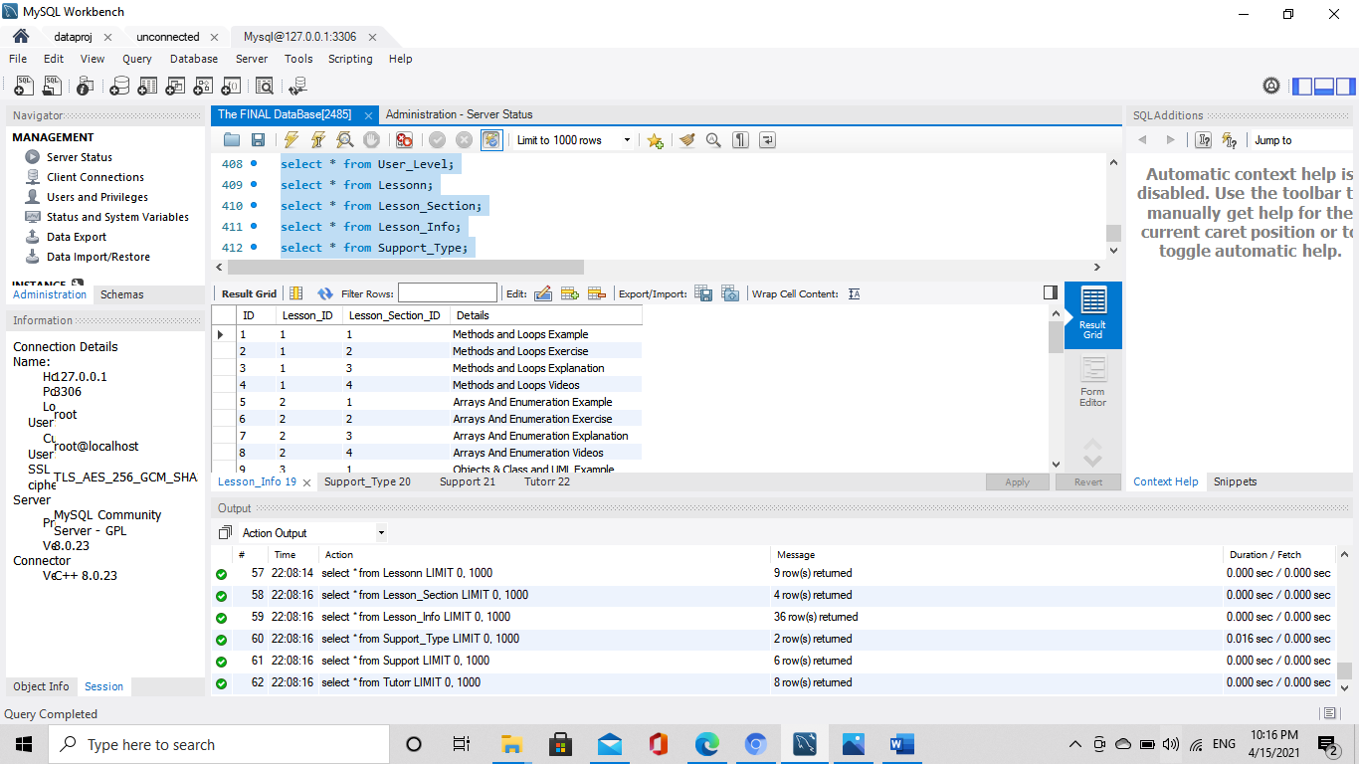

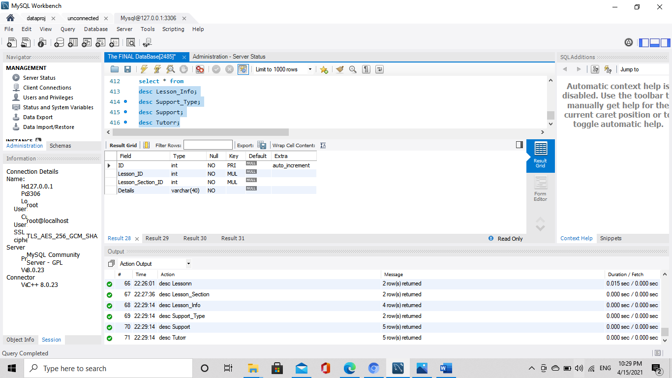

CREATE TABLE Lesson_Info (

ID int(11) NOT NULL AUTO_INCREMENT,

Lesson_ID int(11) NOT NULL,

Lesson_Section_ID int(11) NOT NULL,

Details varchar (40) NOT NULL,

PRIMARY KEY (ID),

KEY Lesson_ID (Lesson_ID,Lesson_Section_ID),

KEY Lesson_Section_ID (Lesson_Section_ID)

);

Support_Type table

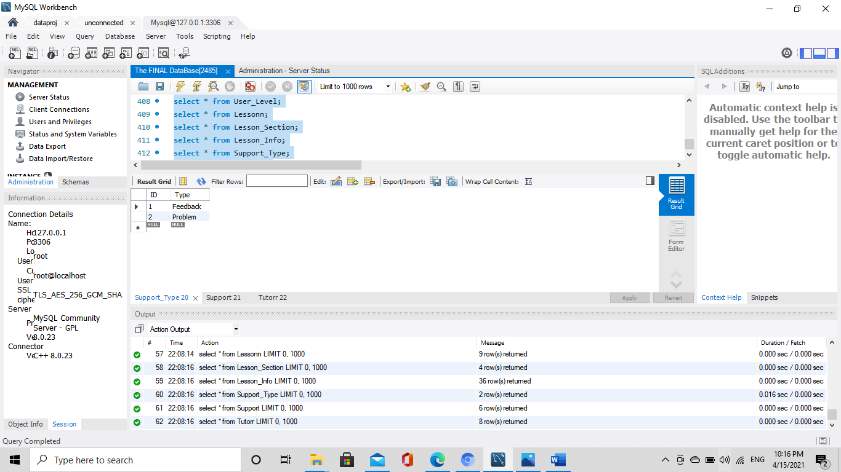

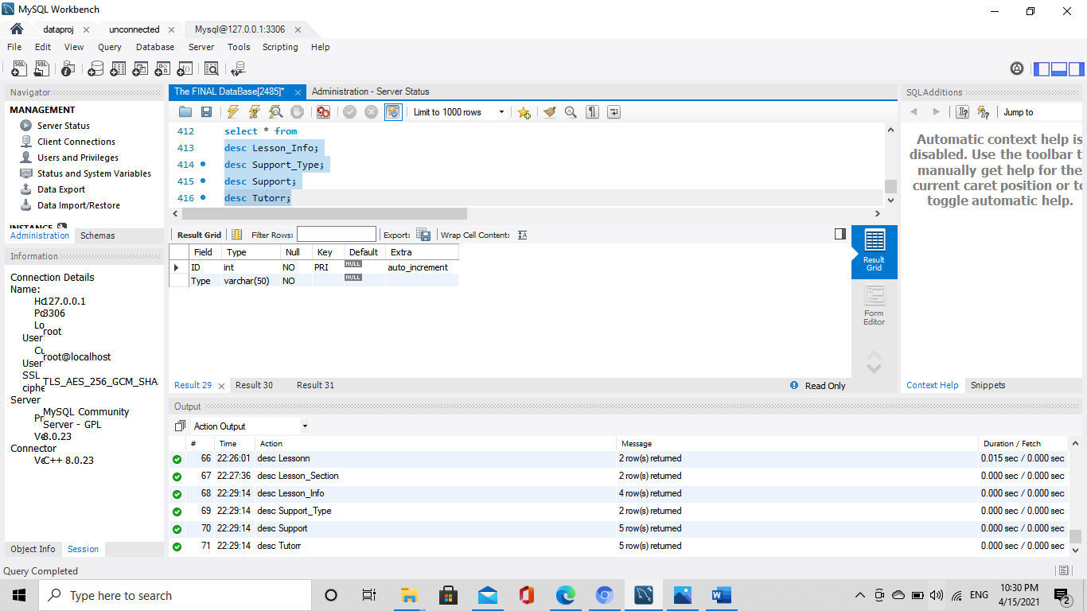

CREATE TABLE Support_Type (

ID int(11) NOT NULL AUTO_INCREMENT,

Type varchar(50) NOT NULL,

PRIMARY KEY (ID)

) ;

**Support table**

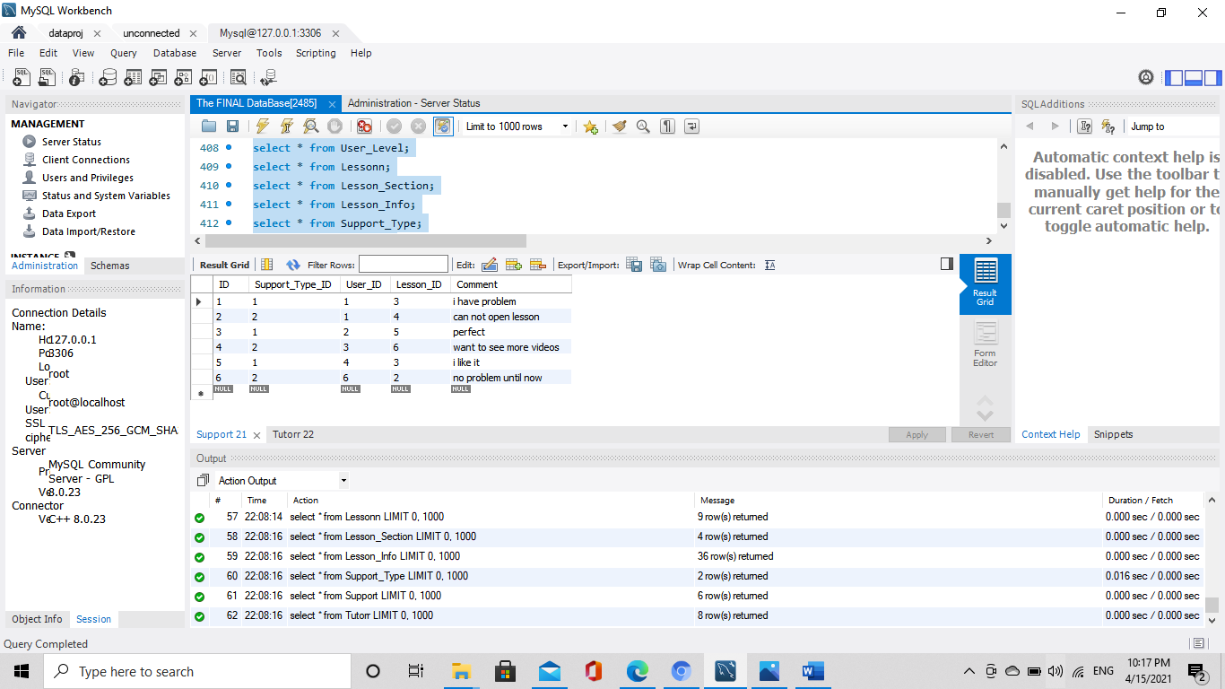

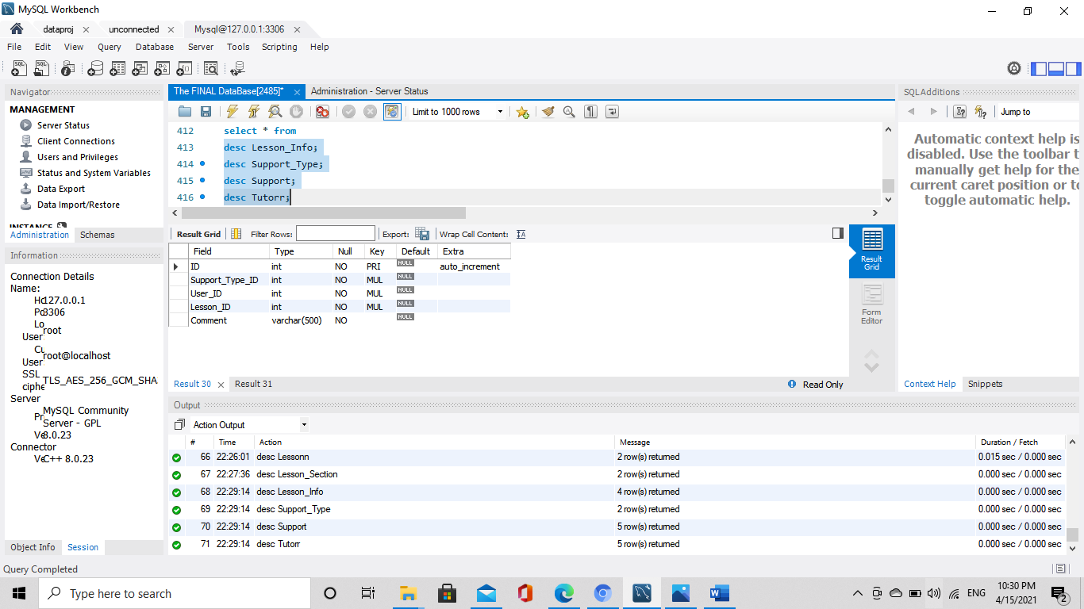

**CREATE TABLE Support (**

**ID int(11) NOT NULL AUTO_INCREMENT,**

**Support_Type_ID int(11) NOT NULL,**

**User_ID int(11) NOT NULL,**

**Lesson_ID int(11) NOT NULL,**

**Comment varchar(500) NOT NULL,**

**PRIMARY KEY (ID),**

**KEY Support_Type_ID (Support_Type_ID),**

**KEY Lesson_ID (Lesson_ID)**

**);**

**Tutor table**

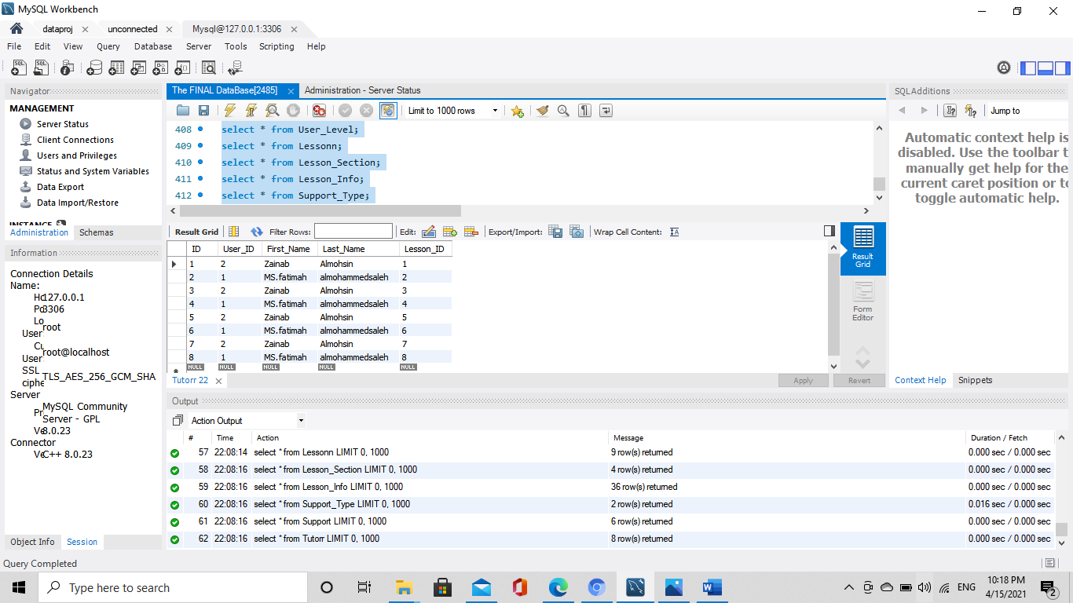

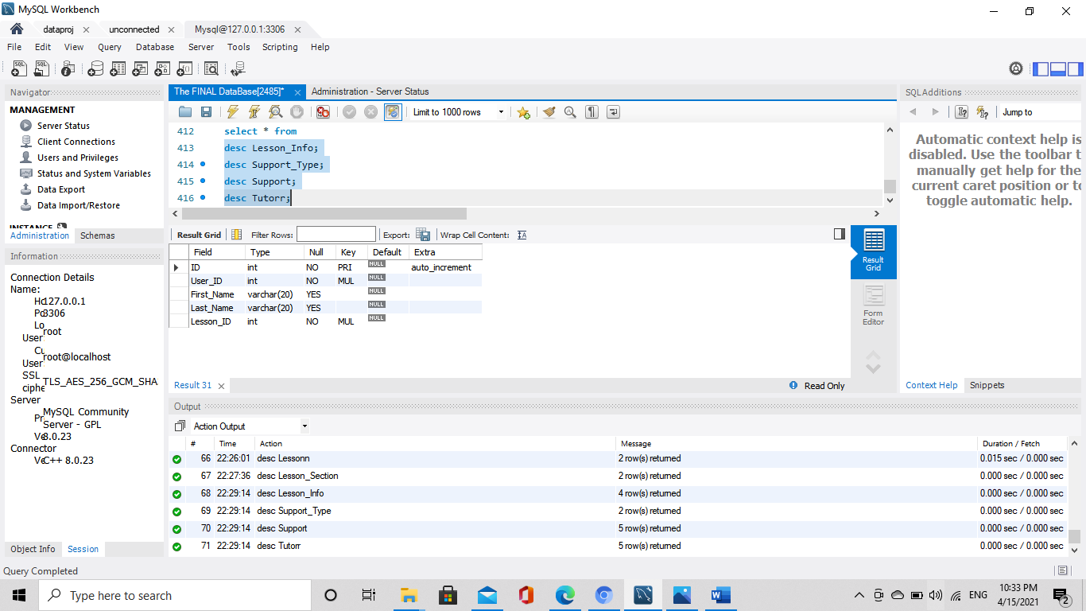

**CREATE TABLE Tutorr (**

**ID int(11) NOT NULL AUTO_INCREMENT,**

**User_ID int(11) NOT NULL,**

**First_Name varchar(20),**

**Last_Name varchar(20),**

**Lesson_ID int(11) NOT NULL,**

**PRIMARY KEY (ID),**

**KEY User_ID (User_ID),**

**KEY Lesson_ID (Lesson_ID)**

**) ;**

**// VIDEO FOR QUERYS**

[**https://udksa-my.sharepoint.com/:v:/g/personal/2190003811_iau_edu_sa/ERCXWRwj76dOodBQkk3rHWkBzBblq3LkYT5Q1yHK8_uxFQ?e=KWJ3ad**](https://udksa-my.sharepoint.com/:v:/g/personal/2190003811_iau_edu_sa/ERCXWRwj76dOodBQkk3rHWkBzBblq3LkYT5Q1yHK8_uxFQ)